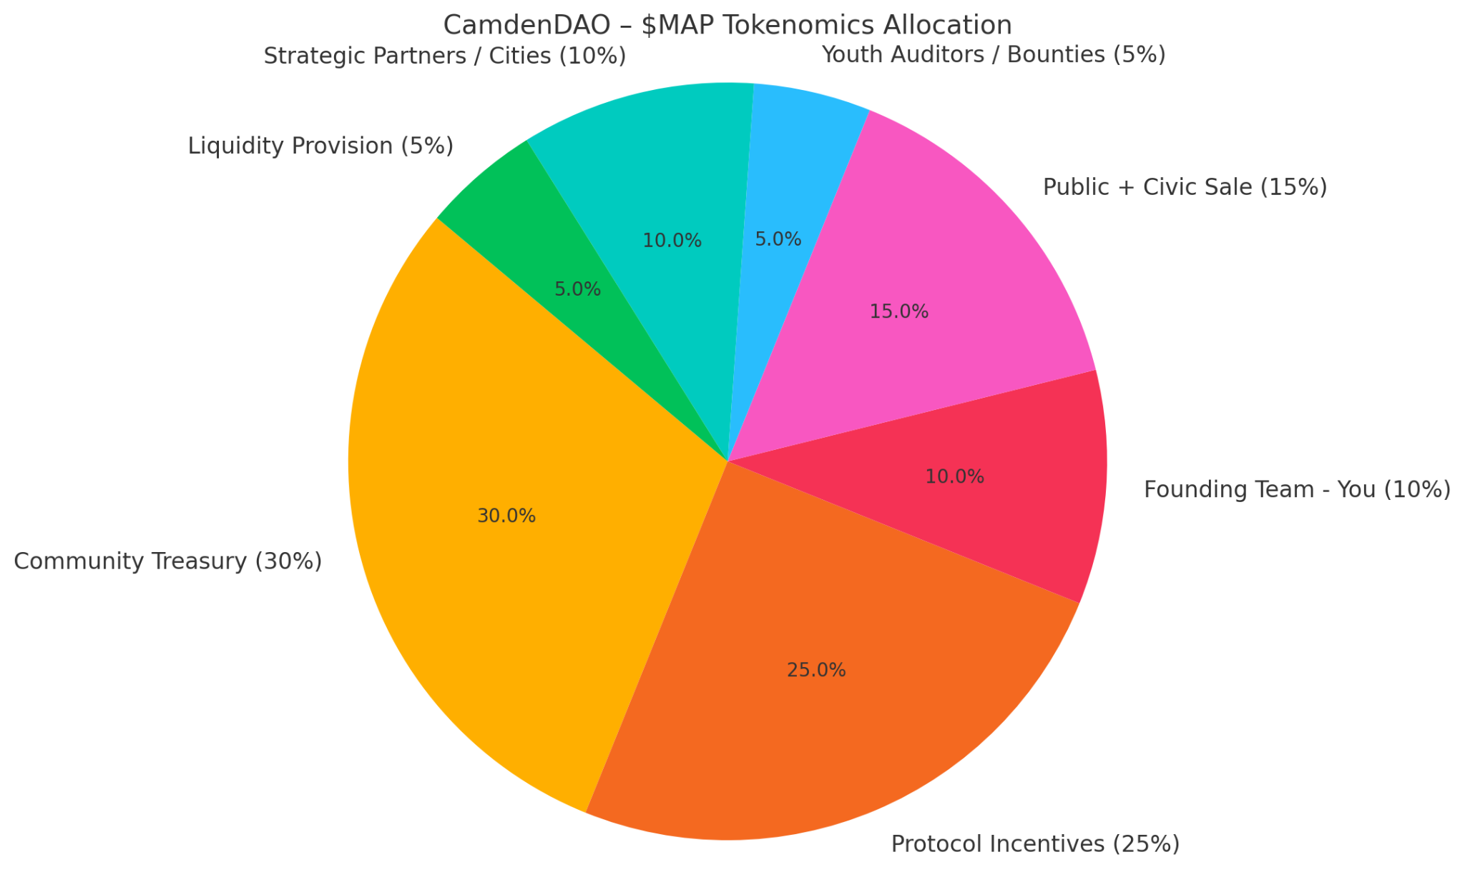

Here’s the tokenomics allocation chart for CamdenDAO’s $MAP token:
- You, as the founding team, hold 10% of tokens — vesting over 4 years
- Community Treasury (30%) funds public upgrades and proposals
- Protocol Incentives (25%) fuel real contribution (like waste detection and consent schemas)
- Other slices ensure governance, adoption, and liquidity happen ethically and transparently

